May 10, 2007

Ed Adelson
Associate Executive Dean
Colleges of the Arts and Sciences
114 U HALL, 230 N OVAL MALL
CAMPUS

Dear Ed,

Subcommittee B of the Colleges of the Arts and Science Committee on Curriculum and Instruction unanimously supported the College of the Art’s proposal for a Minor in Video Arts. A group of five faculty, led by Amy Youngs, Assistant Professor in the Department of Art, is proposing this minor. The Video Arts Minor will bring together courses from five units within the college to make a cohesive package for students who wish to focus on the making of video art. As stated in the proposal, the minor is distinct from the minor in Media Production and Analysis and the major in Film Studies because it focuses on the “hands on” aspect of video art and its integration with artistic endeavors.

The focus of the minor is to incorporate the medium of video art “into traditional art and/or narrative practices, as well as, those interested in creating experimental artworks that are expressed entirely within the format of video. Students are currently pursuing their interests by taking individual courses within the college; we believe that this will provide transparency of and consistency of curricular offerings for these students.”

The following is a synopsis of the areas within the minor:

- Foundation Courses (5 credit hours)
- Core Courses Basic Tools and Concepts (5-10 credit hours)
- Core Courses Issues and Techniques (5-10 credit hours)
- Electives (remaining credit hours to total 25 credit hours)

We forward it on to you so that it may go through the appropriate channels. When the CCI reviews the proposal, we ask that you invite Professor Youngs to the meeting. She can be reached at 292-5072 or through email at youngs.6@osu.edu.

If you have questions about the proposed change, please feel free to contact me at 292-5171 or through e-mail, mockabee.1415.

Thank you,
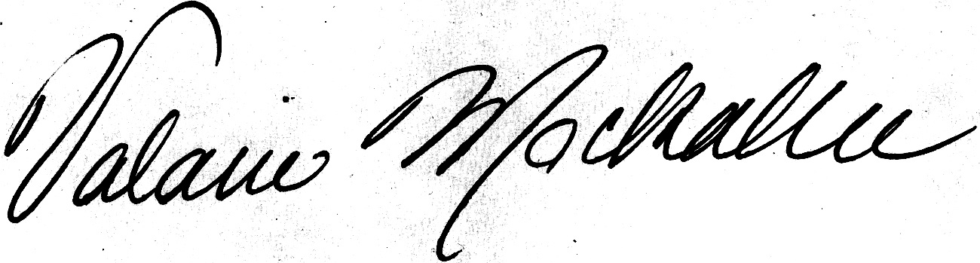
Valarie Mockabee
Chair, Subcommittee B of the ASC CCI

cc: Amy Youngs, Department of Art
Jessica Mercerhill, ASC Curriculum Director

